# Referencing Code

This guidance is for all University of Sheffield Library [Referencing styles](https://www.sheffield.ac.uk/library/idlt/referencing). You will need to adapt this guidance to your referencing style.

It’s important to acknowledge the source of code just like you would acknowledge the source of any work that is not your own. Referencing correctly will help to distinguish your work from others, give credit to the original author and allow anyone to identify the source.

If you do not reference code correctly this can be seen as [plagiarism](https://www.sheffield.ac.uk/ssid/unfair-means/index).

## When to reference

It’s not always easy to decide what should and shouldn’t be referenced and you may need to use your own judgement to make a decision.  If you are unsure please check with your module tutor.

For example, a common function or common approach in programming may not need to be referenced. If you have used a source to check the order of arguments in a function this may not need to be referenced, but if you have copied and pasted a substantial amount of code that is not your own this would need to be referenced.

The general principle is, if you did not create the code you should credit the original author. You should also check that the code’s licence allows you to use it, and remember to include any material that the author has said must be included in any copy.

Example code licence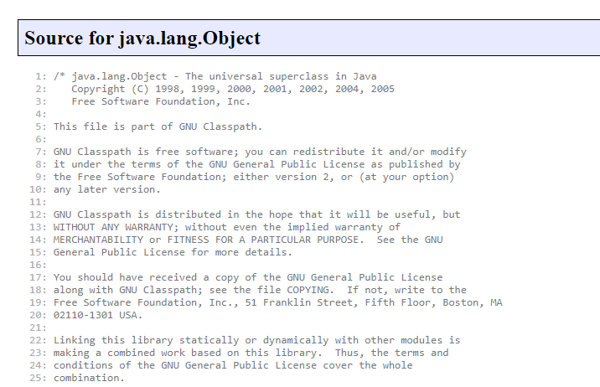

Taken from: GNU Classpath developer resources, *Source for java.lang.Object*  http://developer.classpath.org/doc/java/lang/Object-source.html

## How to reference

There are two different ways to reference code in your work. In both approaches you would include a citation (acknowledgement) close to the material it relates to.

### Citing code in a written assignment

If you include or mention code (that is not your own) in the body of your work you need to add a citation in the text, just as you would when quoting or paraphrasing text. A full reference to the source should then be added to the reference list at the end of your assignment.

Examples are given below in the IEEE and APA style. If you are using a different style of referencing take the elements of the reference and create it in that style.

#### IEEE example

##### In the body of your assignment

Enclosed number in square brackets, e.g. [2]

##### In the reference list

[ 2 ] INITIAL(S). Surname, Title of program or source code*,* Version number, Year. [Source Code]. Accessed: Abbrev. Month. Day, Year. Available: URL or publisher.

[ 2 ] C. Parnot, Cellular and Molecular Bioengineering, 1.0, 2012. [Source Code] Accessed: Aug. 15, 2020. Available: https://github.com/citation-style-language/styles/blob/master/cellular-and-molecular-bioengineering.csl

#### APA example

##### In the body of your assignment

(Parnot, 2020)

Parnot (2020)

##### In the reference list

Surname, INITIAL(S). (Year). Title of program or source code*,* Version number [Source Code]. Publisher. URL

Parnot, C. (2012). Cellular and Molecular Bioengineering*,* 1.0. [Source Code]. GitHub. https://github.com/citation-style-language/styles/blob/master/cellular-and-molecular-bioengineering.csl

### Including a citation when writing code

If you use or adapt code that is not your own you need to acknowledge the original source by including a comment in your code giving the relevant details. This is placed near the reused code and contains much of the same information you would use when constructing a reference within a written assignment:

Author(s) / organisation or company

Title of program or source code

Version number

Date / Year

Type e.g. computer program or source code

Availability (e.g. URL or publisher)

**Example:**

# FizzBuzz implementation in Ruby

# Oliver Atkinson (09 Feb 2014)

# https://stackoverflow.com/a/21666168 [accessed 02 Sep 2019]

1.upto(100) do |i|

  string = ‘’

  string += ‘Fizz’ if i % 3 == 0

  string += ‘Buzz’ if i % 5 == 0

  puts "#{i} = #{string}"

end

Remember you should always check the terms of licence of the code you wish to use. Even if code is open source you should still reference the source as it’s not your own work.

## Useful links

Choosing a licence - [Choose an open source license](https://choosealicense.com/)

This website also provides a [digest of licences](https://choosealicense.com/appendix/)

## Full URLs

Referencing styles: <https://www.sheffield.ac.uk/library/study/research-skills/referencing>

Plagiarism: <https://www.sheffield.ac.uk/ssid/unfair-means/index>

Choose an open source licence: <https://choosealicense.com/>

Digest of licences: <https://choosealicense.com/appendix/>

Last reviewed: August 2024

Review due: Summer 2025



Except otherwise noted, this work by The University of Sheffield Library is licensed under the Creative Commons Attribution-NonCommercialShareAlike 4.0 International License. To view a copy of this license, visit http://creativecommons.org/licenses/by-nc-sa/4.0/.